/* Ashok IPBC Mortgage Project R1SP2Story2 7.23.19*/

Homework:

4. Complete R1:SP2: Story 2 – Read the 3 Different file types for all Input Data. Explain the entire process with explanations &amp; screenshots.

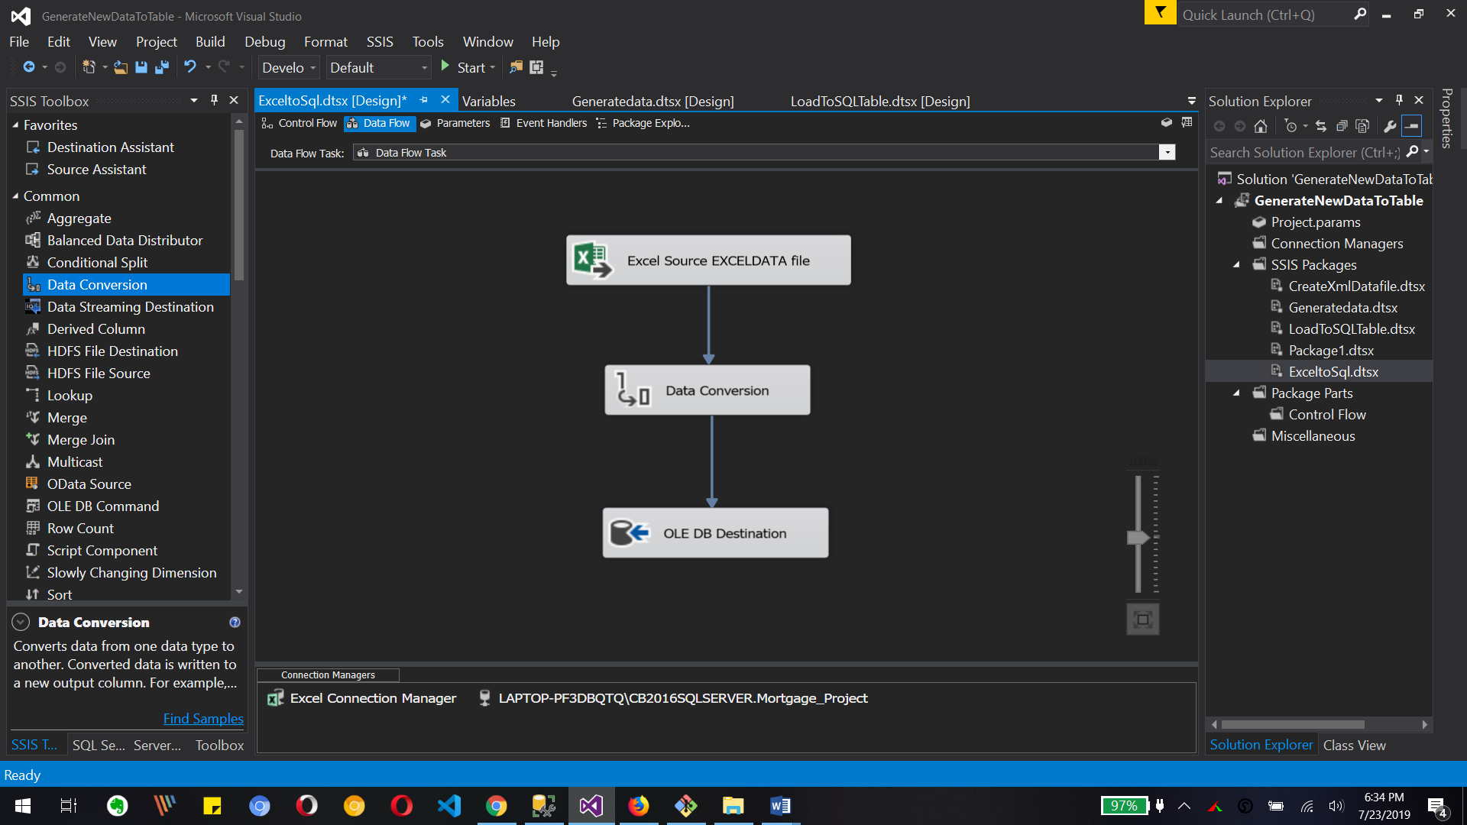

Above image shows the reading excel file and converting it and loading data to sql database

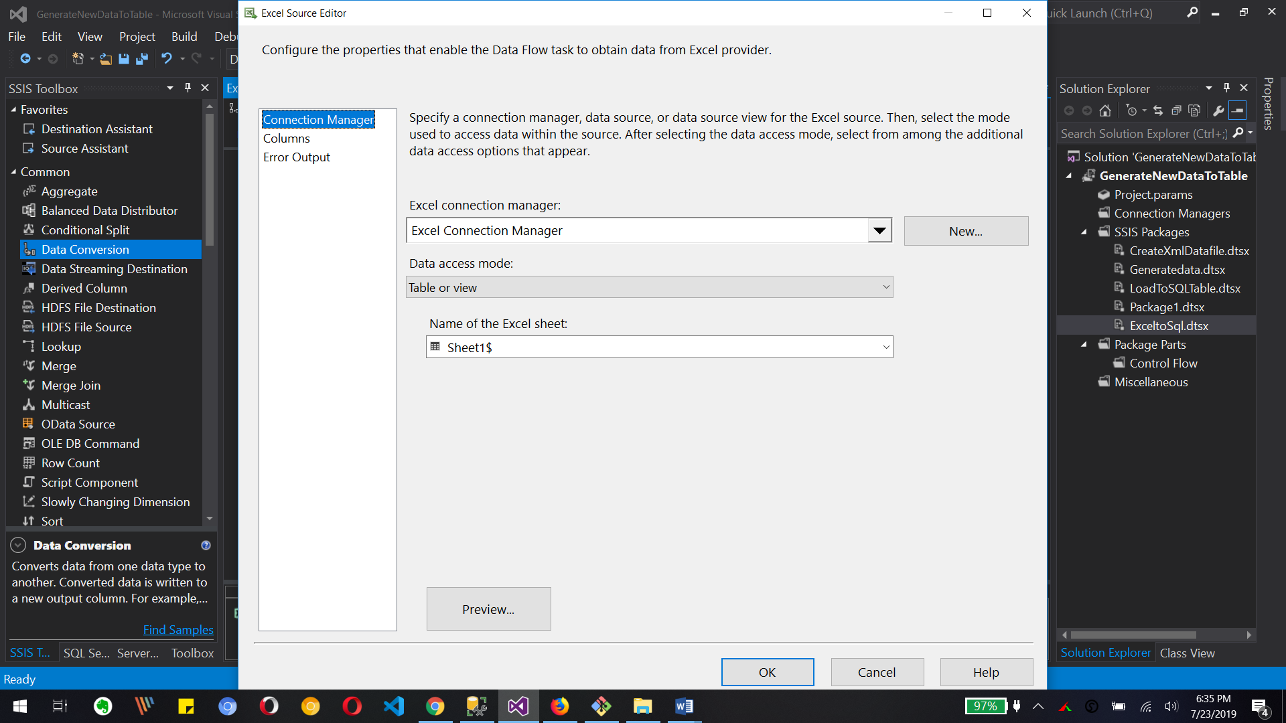

We need to select excel file for data load as source file and it’s specific sheet to get data

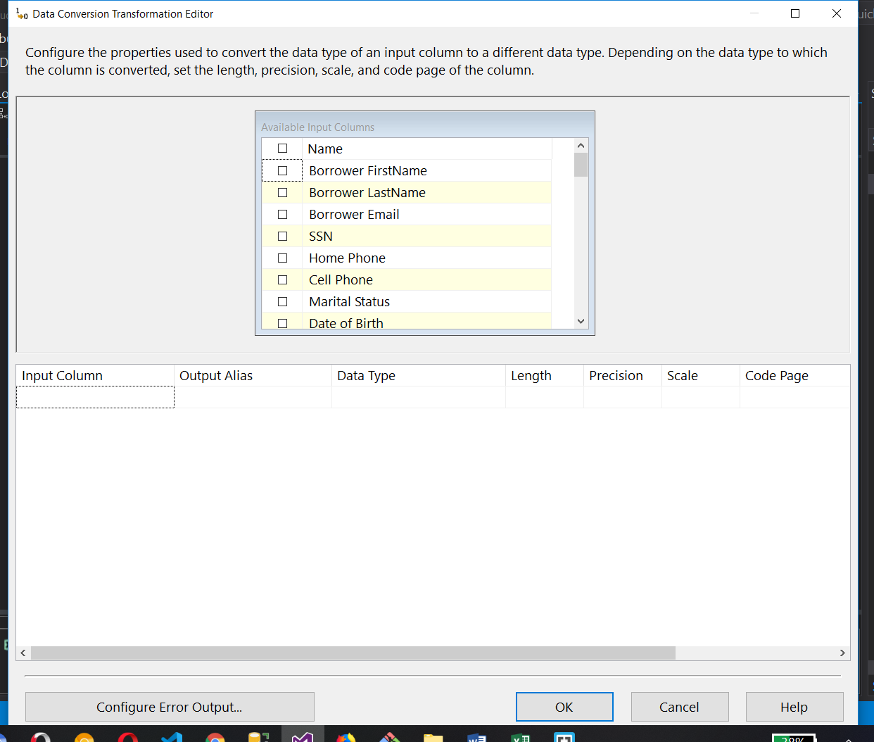

Above image is for data conversion transformation editor for selecting columns and changing it datatypes

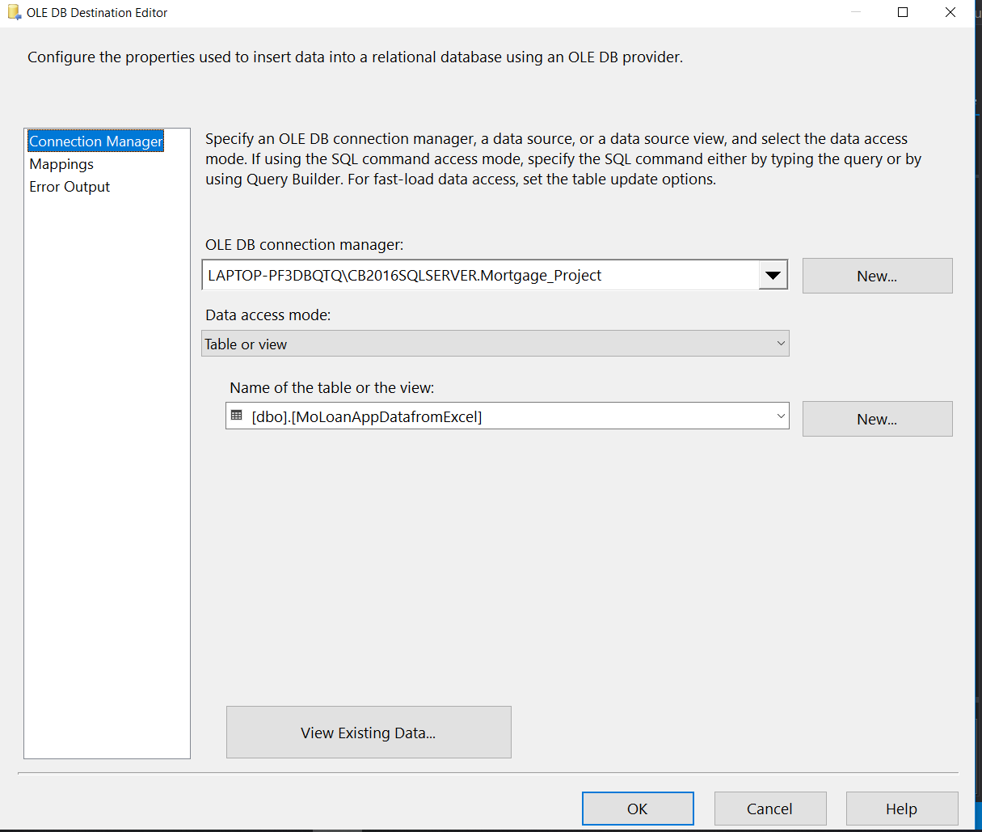

Above is conncetion to fina database and its table.

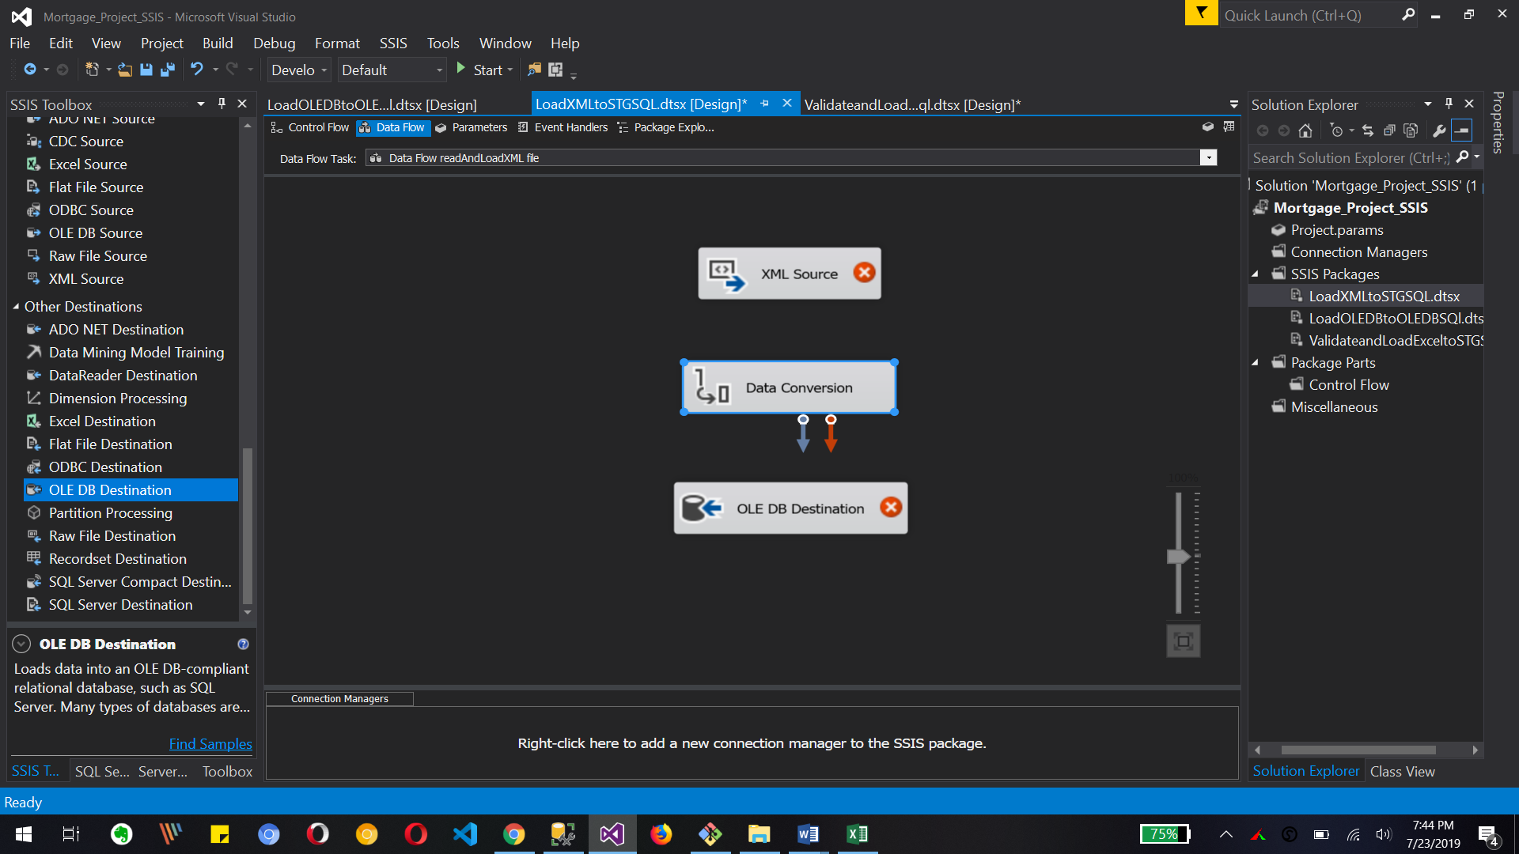

Above image is for XML data load to sql database table

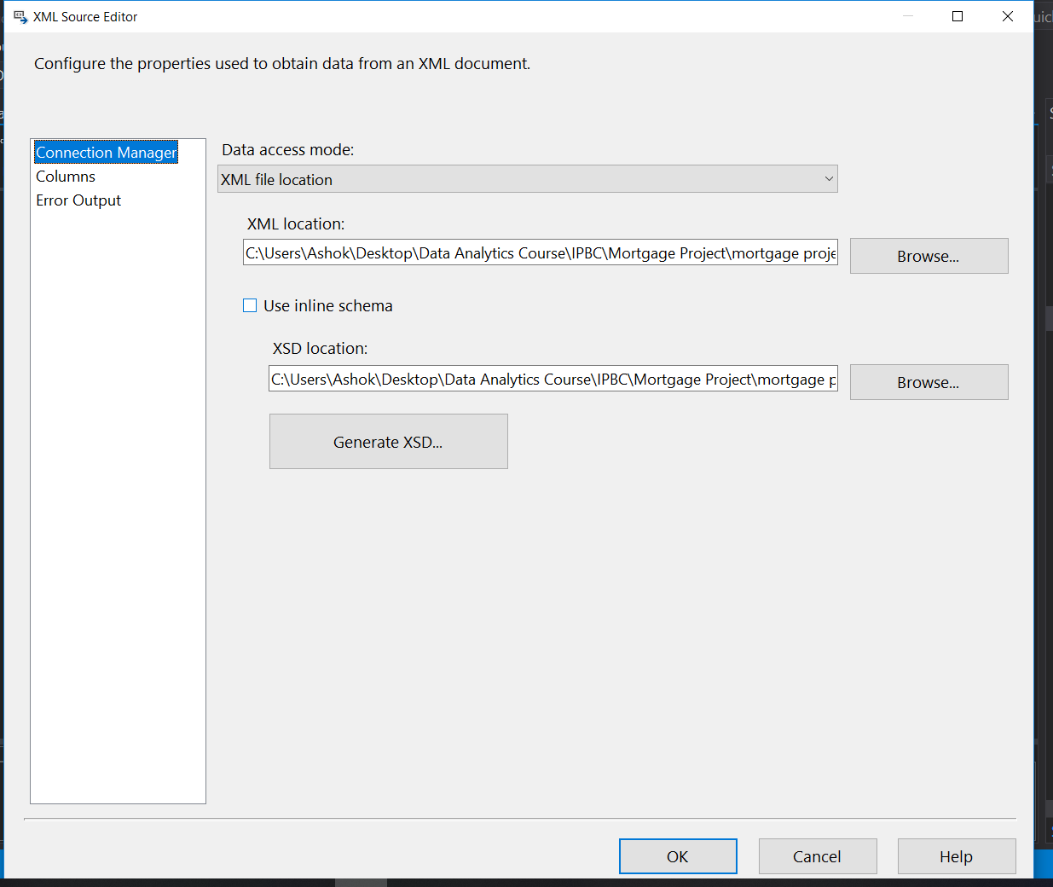

The above image shows the link location for xml file and xsd file to validate xml file from system.

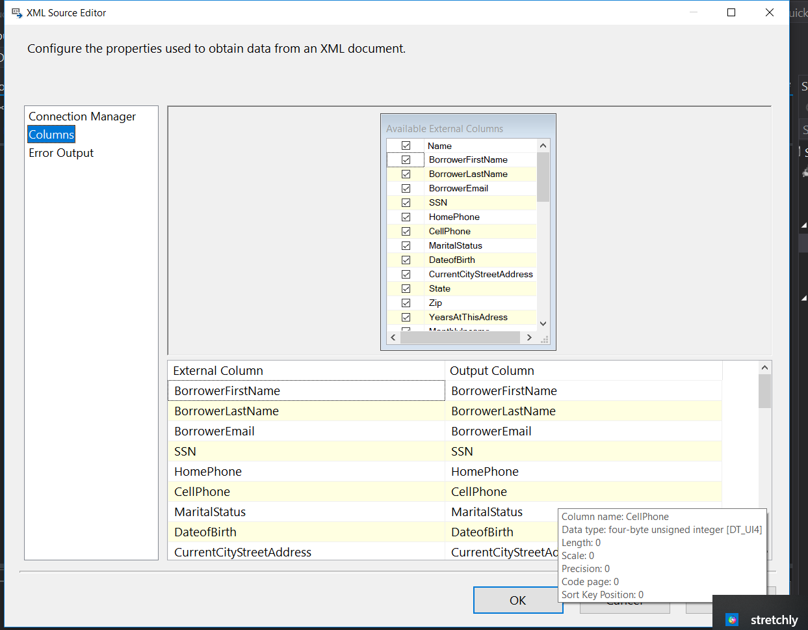

These columns are from xml file so we select them to load into database table

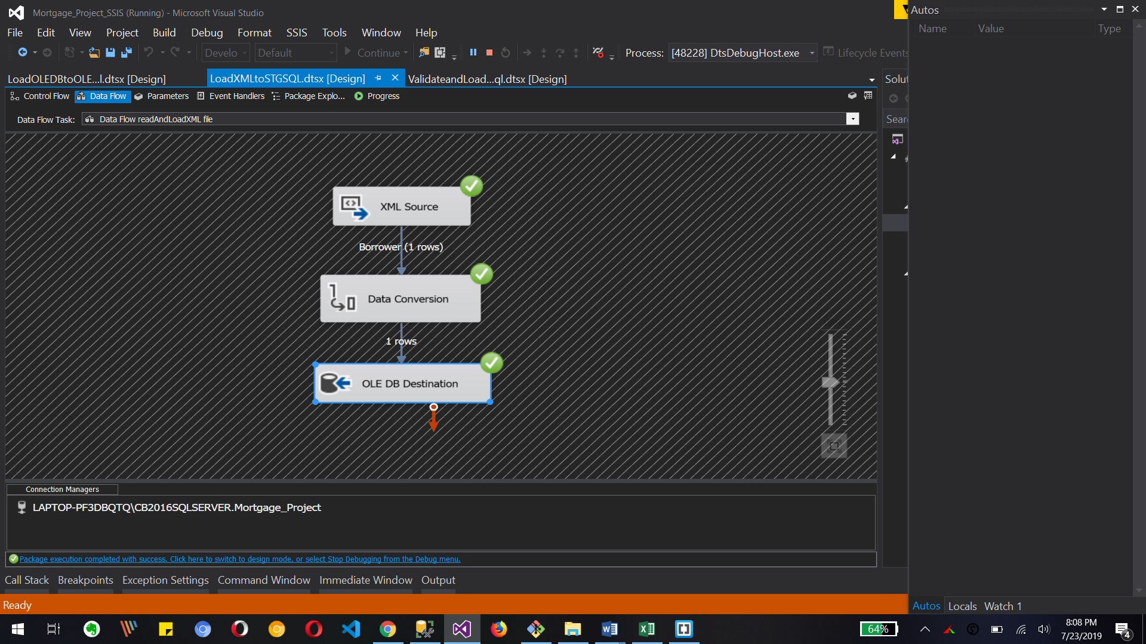

Above image shows the completed package execution for xml source to oledb destination.

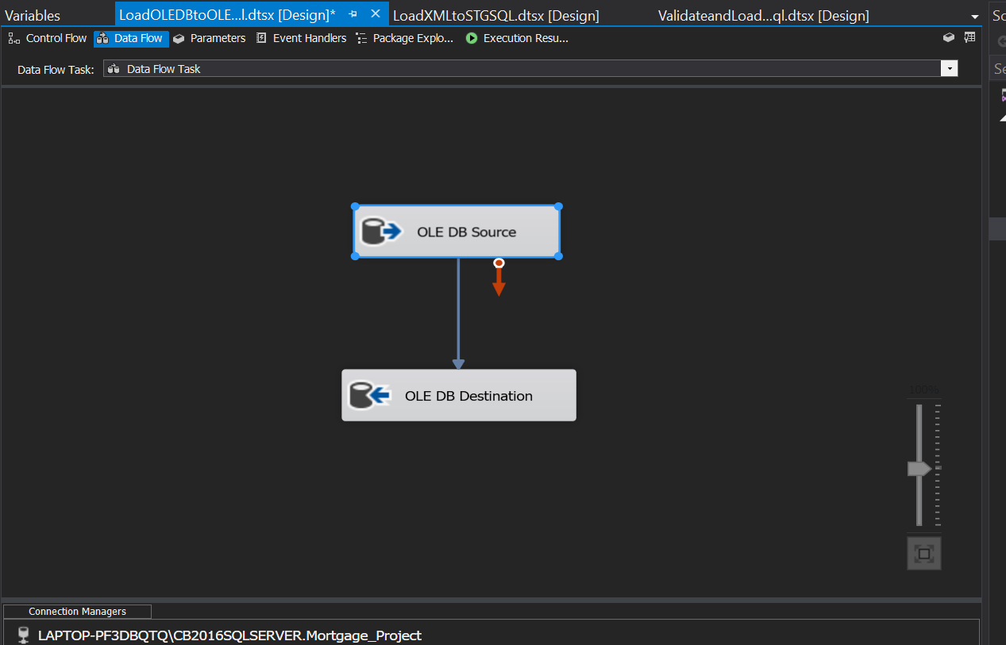

Above image is for oledb table data to oledb table load and transformation. Here is same as source to destination connection for two different tables.

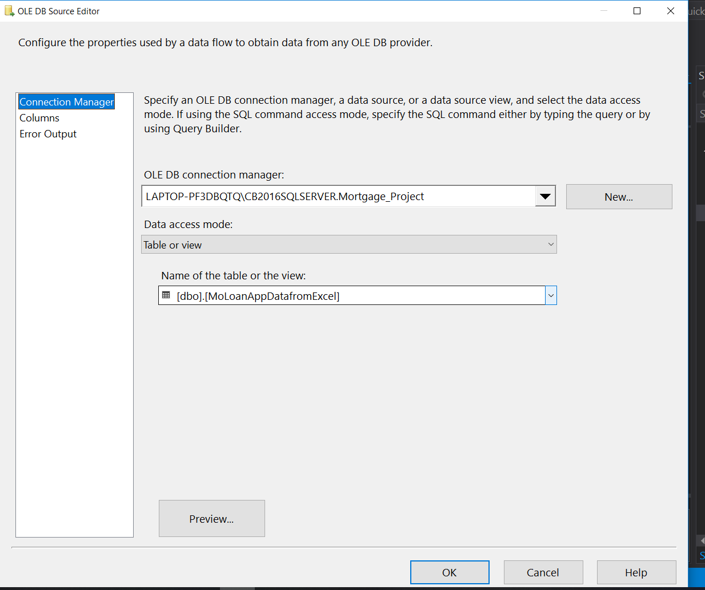

Server and Database connection and selecting it’s table for data transform.



Above is the Columns of table which needs tobe mapped to new table of oledb table.

What to Submit:

* Copy and paste the link to your video(s) as part of your homework.

1. SQL BI Interview Questions: SSIS – How do you load XML files

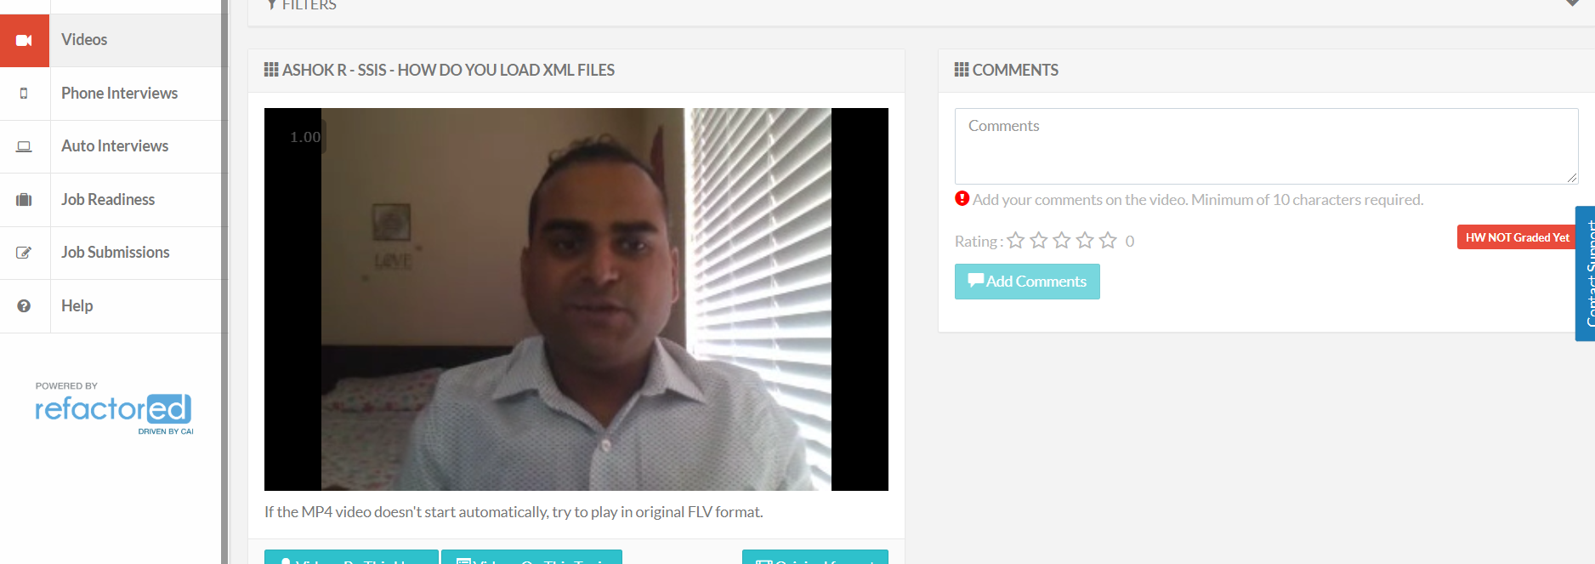

2. SQL BI Interview Questions: SSIS – Name 3 transformations you have used and how

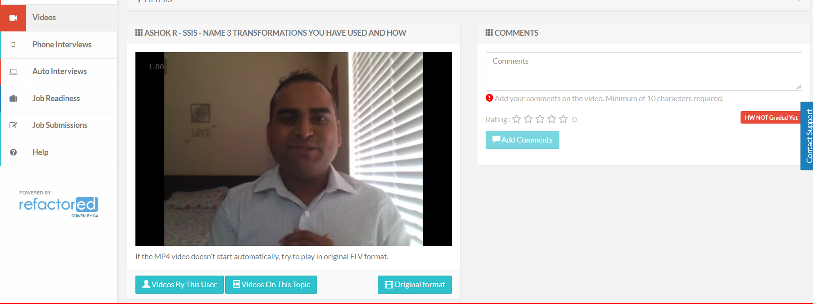

* Watch, Comment &amp; take screenshots of your comments from 3 other videos on the same topic (per question). Comments must be 20+ characters. Leave comments based on presentation, delivery and/or technical details. Your critiques will help you be more conscious of your own videos. (3 comment screenshots per Video Question)
  1. Xml File source

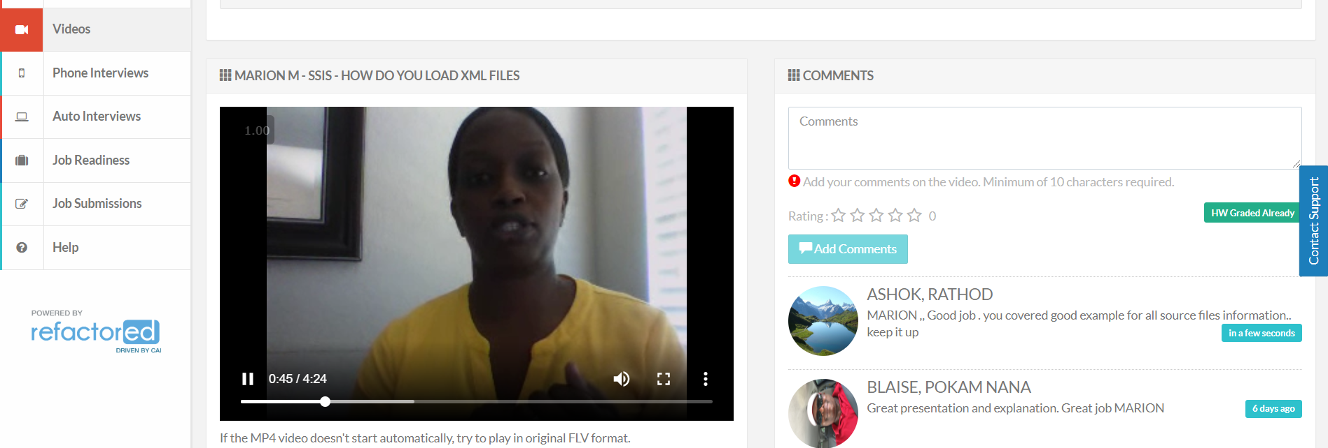

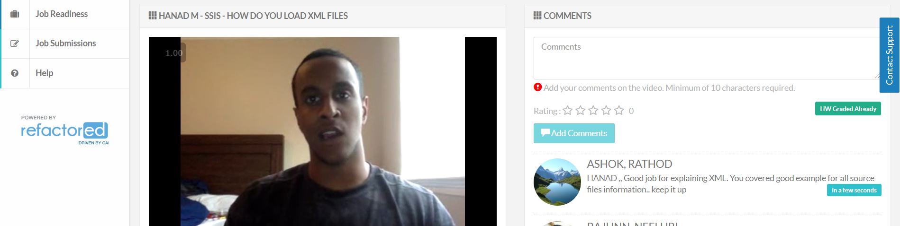

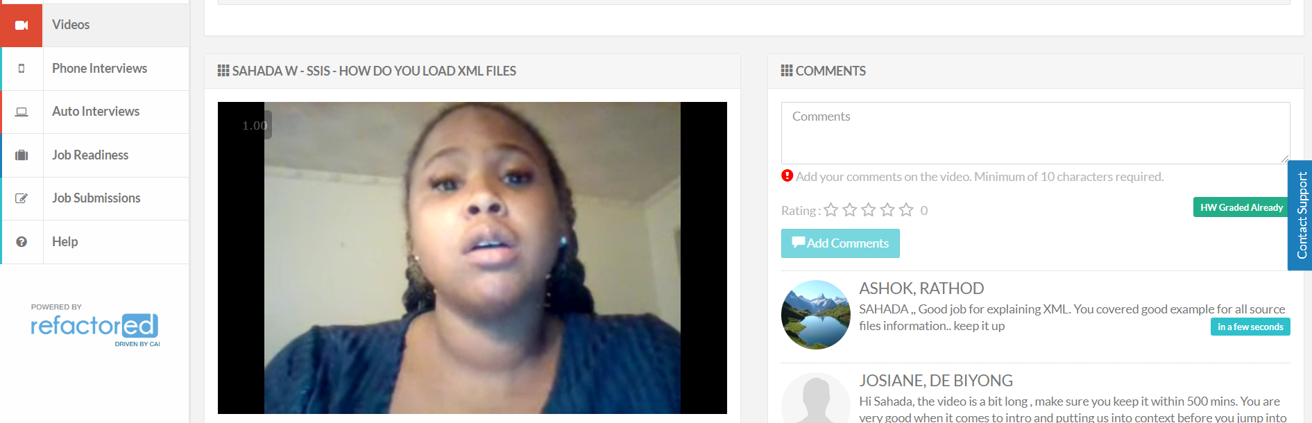

* **NAME 3 TRANSFORMATIONS YOU HAVE USED AND HOW**

